DiceyWords
First the motivation:
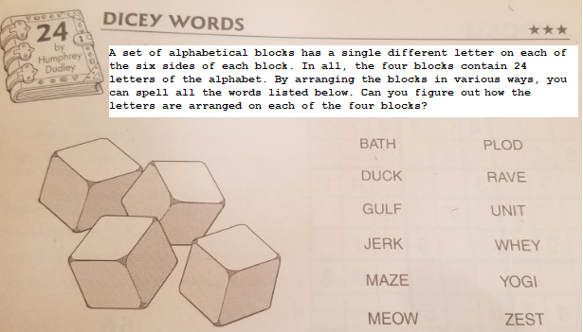

Special note: All Letters will be UPPER CASE letters.
Special note: No die may be used more than once.
You will implement the constructor and three methods in the DiceyWords class. The constructor has a String[][]die parameter representing four 6-sided die. die[0] represents one die, die[1] represents another die, and so on. Each die will contain 6 individual letters. No letter will appear on more than one die, and no letter will appear more than once on a given die.

The three methods are getImpossibleWords (ArrayList<String> words), missingDie(String[][] die, ArrayList<String> words), and unusedLetters(ArrayList<String> words).

The getImpossibleWords(ArrayList<String> words) returns a List<String> containing all words in the parameter words that cannot be spelled with the four die passed to the constructor.

See next page for sample code.
The following code shows the results of the getImpossibleWords method.
The following code | Returns
String[][] dice = { {"A", "W", "K", "U", "C", "X"},
{"B", "E", "S", "I", "G", "Q"},
{"T", "Z", "O", "R", "Y", "N"},
{"H", "M", "J", "D", "P", "F"}};
// note missing letters: "L” and “V"
DiceyWords dw = new DiceyWords(dice);
ArrayList<String> words = new ArrayList<String>();
words.add("BATH");
words.add("MAZE");
words.add("MEOW");
words.add("WHEY");
words.add("JERK");
words.add("PYIC");
words.add("RASH");
words.add("BARD");
words.add("JUST");
words.add("MINX");
words.add("QUOD");
words.add("FRAG");
dw.getImpossibleWords(words).size();  // every word in words can be spelled with the four die */ | 0
words.add(0, "FLAG");
// add the word FLAG which cannot be spelled with the four die

words.add("WAKE");
// add the word WAKE which cannot be spelled with the four die

words.add("MASS");
// add the word MASS which cannot be spelled with the four die
// This implies any word with duplicate letters cannot be
// spelled with the four die
List<String> sol = dw.getImpossibleWords (words);
sol.size(); | 3
sol.contains("FLAG"); | true
sol.contains("WAKE "); | true
sol.contains("MASS "); | true

The missingDie(String[][] die, ArrayList<String> words) has two parameters. The parameter String[][] die represents three 6-sided die. die[0] represents one die, die[1] represents another die, and die[2] represents the third die. Each die will contain 6 individual letters. No letter will appear on more than one die, and no letter will appear more than once on a given die. The ArrayList<String> words contains a List of words with length 4. This method is to return a String with length 6 containing the letters required on the missing fourth die allowing each word in words to be spelled. You may assume the String returned by the missingDie method will always contain 6 letters.

The following code shows the results of the missingDie method.
The following code | Returns
String[][] d = { {"A", "W", "K", "U", "C", "X"},
{"B", "E", "S", "I", "G", "Q"},
{"H", "M", "J", "D", "P", "F"} };

ArrayList<String> ws = new ArrayList<String>();
ws.add("BATH");
ws.add("MAZE");
ws.add("MEOW");
ws.add("WHEY");
ws.add("JERK");
ws.add("PYIC");
ws.add("RASH");
ws.add("BARD");
ws.add("JUST");
ws.add("MINX");
ws.add("QUOD");
ws.add("FRAG");
String strSol = dw.missingDie (d, ws);
strSol.length() | 6
"TZORYN".indexOf(strSol.substring(0, 1) >= 0); | true
"TZORYN".indexOf(strSol.substring(1, 2) >= 0); | true
"TZORYN".indexOf(strSol.substring(2, 3) >= 0); | true
"TZORYN".indexOf(strSol.substring(3, 4) >= 0); | true
"TZORYN".indexOf(strSol.substring(4, 5) >= 0); | true
"TZORYN".indexOf(strSol.substring(5, 6) >= 0); | true
Yes, this implies strSol is a permutation of the letters: "TZORYN"

The unusedLetters(ArrayList<String> words) has the single parameter ArrayList<String> words which contains a List of words with length 4. This method is to return a String[]containing all letters from the four die that were not needed to spell any word in words.
The following code shows the results of the unusedLetters method.
The following code | Returns
String[][] dice = { {"A", "W", "K", "U", "C", "X"},
{"B", "E", "S", "I", "G", "Q"},
{"T", "Z", "O", "R", "Y", "N"},
{"H", "M", "J", "D", "P", "F"}};
DiceyWords dw = new DiceyWords(dice);
ArrayList<String> moreWords = new ArrayList<String>();
moreWords.add("BATH");
moreWords.add("MAZE");
moreWords.add("MEOW");
moreWords.add("WHEY");
moreWords.add("JERK");
moreWords.add("PYIC");
moreWords.add("RASH");
moreWords.add("BARD");
moreWords.add("JUST");
moreWords.add("MINX");

String letters = dw.unusedLetters(moreWords);
letters.length(); | 3
"FGQ".indexOf(letters.substring(0,1)) >= 0; | true
"FGQ".indexOf(letters.substring(1,2)) >= 0; | true
"FGQ".indexOf(letters.substring(2,3)) >= 0; | true
“FGQ” are the only letters not used by any word in words on the four die
Yes, this implies letters is a permutation of the letters: "FGQ"
moreWords.add("FGQT");

letters = dw.unusedLetters(moreWords);
letters.length(); | 0
Adding a word that requires the letters “FGQ” to words will require all letters on the four die be used

